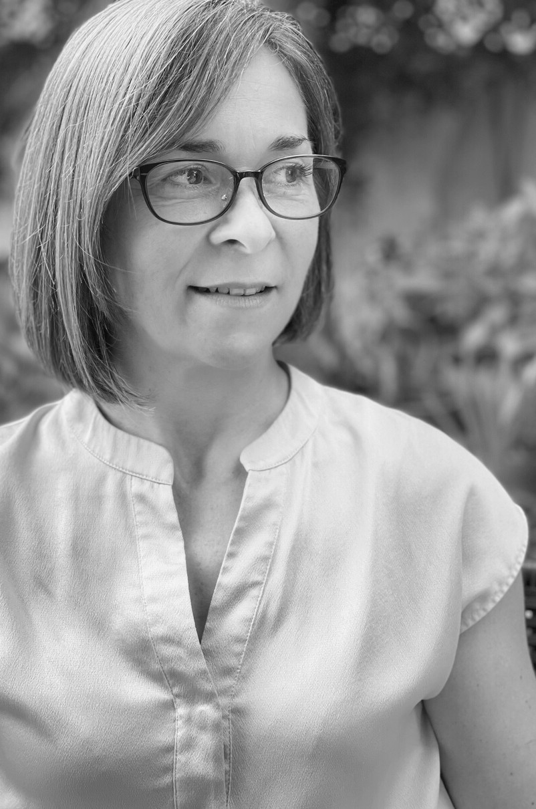
SARAH
MILLSON
SENIOR CONSULTANT
A BIT ABOUT ME
I'm an enthusiastic facilitator and trainer specialising in developing individuals and teams across industries
including finance and media through long-lasting and powerful learning experiences. I've facilitated sales
transformation, leadership development, negotiation and communication skills training, and have experience in
corporate role play.
MY VALUES
People are my passion: learning from them, empowering them, developing them. I believe we each have the power
to change ourselves and the world around us, we just need
to be shown the tools to unlock our potential.
I ' VE WORKED WITH...
HSBC DBS
BNP Paribas PayMe
AXA UBS
BFAM
Cartier

POSITION

SENIOR CONSULTANT

CORE SKILLS

NEGOTIATION SKILLS
COMMUNICATION SKILLS SALES TRANSFORMATION
LEADERSHIP DEVELOPMENT CULTURE CHANGE
SOCIAL TRANSFORMATION

BACKGROUND

Sharing knowledge and information has always been a driving factor in my life, prompting me to embark on a 20-year career in journalism, first in the
United Kingdom and later in Hong Kong. Editorial management and training became a core element of my two decades in journalism, during which I
designed and delivered newsroom upskilling. I also lectured in the subject at Hong Kong Baptist University.

In recent years, my focus moved towards Learning and Development which led me to Actualize. I love the unique way in which we deliver powerful
programs that have a lasting impact on organisations. I have extensive
experience in sales and negotiation training as well as communication skills and wellbeing programs. I am proficient in delivering both virtual and face- to-face programs.

QUALIFICATIONS & CERTIFICATIONS

Advanced Credit Negotiation Skills (ACNS) Accredited Facilitator Heartstyles Life Indicator Accredited Facilitator & Coach
NLP Coach and Practitioner
Time Line Therapy® Practitioner
Pre-entry Newspaper Journalism (National Council for the Training of Journalists)
Teaching English as a Foreign Language (TEFL)
International Certified Personal Trainer (National Academy of Sports Medicine)

LANGUAGES

English

WILLING TO TRAVEL

Yes

